Home.html:

<html>

<head>

<br>

<p style="font-size:20px">

&nbsp; &nbsp;

<a href="home.html">Home </a> &nbsp; &nbsp;

<a href="advertisement.html"> Advertisement </a> &nbsp; &nbsp;

<a href="registration.html"> Registration </a> <br>

</p>

</head>

<body bgcolor="#FFFFCC">

<p>

There is no shortage of books dedicated to the topic of photography. Despite photography’s relative youth, countless words have been dedicated to this craft, which uses a little magic box to convert the intangible quality of light into something tangible, a photograph.

</p>

<p>

I’ve learned from and been inspired by many of these same books, and I have to admit some feelings of intimidation at the thought that I have something to contribute. Yet, despite these feelings, I have every confidence that what I share here will help to contribute to your passion for photography.

</p>

<p align="justify">

<img src="media/3.jpg" width="760" height="460" align="middle">

</p>

<p>

It’s not because I believe that my way is the better or best way to approach photography. I don’t dare make that claim. What I do know, however, is that I’ve been blessed with the gift of seeing, and that gift has been nurtured by the words I’ve read, the photographs I’ve seen, and the photographers I’ve met. That gift becomes valuable only when I make the choice to share it with others. Sometimes that sharing comes in the form of a photograph, but it also takes shape when I help inspire others to discover their own unique ways of seeing. If you become a better photographer as a result of the words and images in these pages, that’s a wonderful thing. However, the worth of this book becomes much more valuable if you discover a completely new way of seeing with and without a camera. That’s my hope for you.

</p>

<p>

Join this online Photography Course and dig Your Photography Talent

</p>

</body>

</html>

Advertisement.html

<html>

<head>

<title> Advertisement </title>

</head>

<body>

<br>

<p style="font-size:20px">

&nbsp; &nbsp;

<a href="home.html">Home </a> &nbsp; &nbsp;

<a href="advertisement.html"> Advertisement </a> &nbsp; &nbsp;

<a href="registration.html"> Registration </a> <br>

</p>

<table border="1">

<tr>

<td width="330" align="center">

<h2> Video Trailer </h2>

</td>

<td>

<embed width="920" height="580" src="media/Nikon D4S Enter the Minds of the Dedicated Trailer.mp4"> </embed>

</td>

</tr>

<tr width="330" align="center" height="580">

<td>

<h2> Image Gallery </h2>

</td>

<td>

<marquee behavior="scroll">

<img src="media/2.jpg" height="400" width="600">

<img src="media/3.jpg" height="400" width="600">

<img src="media/4.jpg" height="400" width="600">

<img src="media/5.jpg" height="400" width="600">

</marquee>

</td>

</tr>

</table>

</body>

</html>

Registration.html

<html>

<head>

<title>

Photography Registration

</title>

</head>

<body background="media/1.jpg" text="#FFFFFF">

<h2 align="center" style="color:#FFFFFF"> Photography Registration </h2>

<p style="font-size:20px" style="color:#FFFFFF">

&nbsp; &nbsp;

<a href="home.html">Home </a> &nbsp; &nbsp;

<a href="advertisement.html"> Advertisement </a> &nbsp; &nbsp;

<a href="registration.html"> Registration </a> <br>

</p>

<form>

<fieldset style="height:auto">

<legend style="color:#FFFFFF">Personal Details</legend>

<table>

<tr >

<td width="100" height="30"> First Name </td>

<td>: &nbsp; <input type="text" name="t1" value="" size="50"> </td>

</tr>

<tr >

<td width="100" height="30"> Last Name </td>

<td> : &nbsp; <input type="text" name="t2" value="" size="50"> </td>

</tr>

<tr >

<td width="100" height="30"> Email </td>

<td> : &nbsp; <input type="text" name="t3" value="" size="50"> </td>

</tr>

<tr >

<td width="100" height="30"> Password </td>

<td> : &nbsp <input type="password" name="t4" value="" size="50"> </td>

</tr>

<tr >

<td width="100" height="30"> Gender </td>

<td>

: &nbsp;

Male <input type="radio" name="r1">

Female <input type="radio" name="r1">

</td>

</tr>

<tr >

<td width="100" height="30"> Age </td>

<td>

: &nbsp;

<select>

<option> 18 </option>

<option> 19 </option>

<option> 20 </option>

<option> 21 </option>

<option> 22 </option>

</select>

</td>

</tr>

<tr >

<td width="100" height="30"> Articles </td>

<td>

: &nbsp;

Landscape Photography <input type="checkbox" title="c1">

Portrait Photography <input type="checkbox" title="c1">

</td>

</tr>

</table>

<table>

<tr>

<td width="300" height="60"> </td>

<td width="90"> <input align="right" type="submit" value="Register"> </td>

<td> <input type="reset"> </td>

</tr>

</table>

</fieldset>

</form>

<embed src="media/The Moon And The Superhero.mp3" height="0" width="0"> </embed>

</body>

</html>

# Output:

Home:

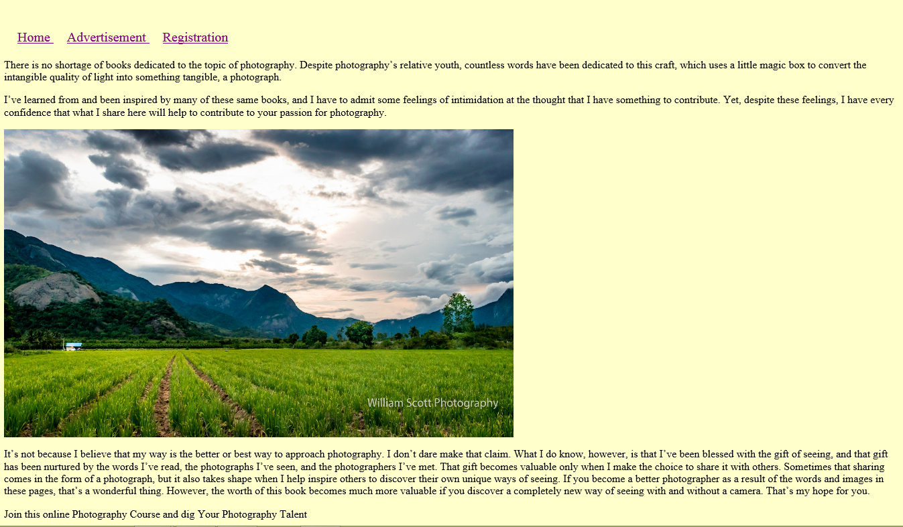

Registration:

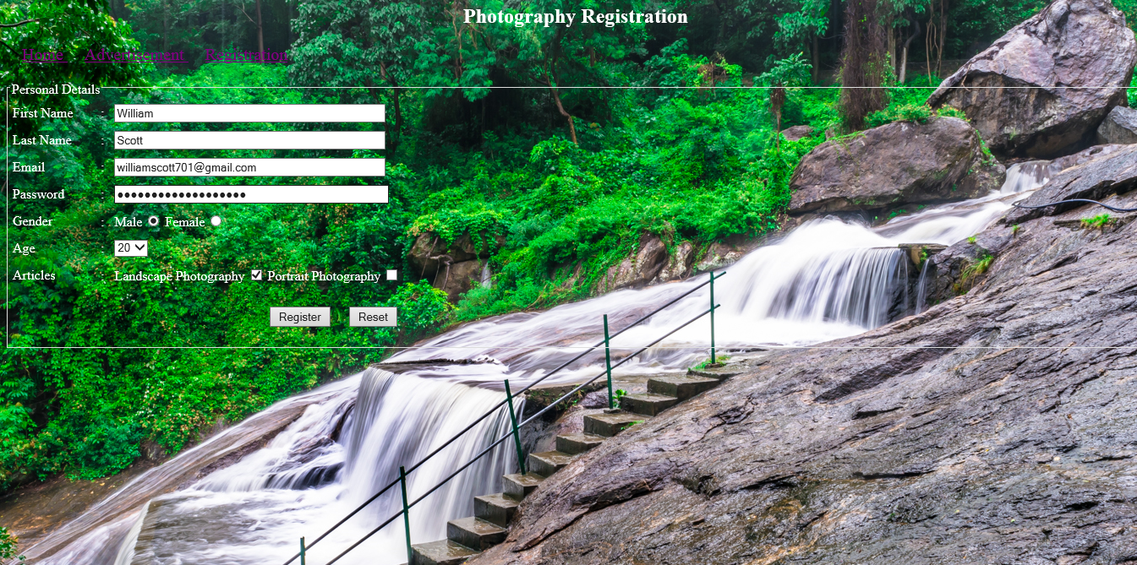

Advertisement:

